***Analysis of Fertility Rates with Special Reference to India***



***Introduction:***

The **Total Fertility Rate (TFR)**, sometimes also called the fertility rate, absolute/potential natality, period total fertility rate (PTFR), or total period fertility rate (TPFR) of a population is the average number of children that would be born to a woman over her lifetime if:

* She was to experience the exact current age-specific fertility rates through her lifetime
* She was to live from birth until the end of her reproductive life.

It is obtained by summing the single-year age-specific rates at a given time. As of 2020, the total fertility rate varied from 0.84 in South Korea to 7.0 in Nigeria. The TFR is not based on the fertility of any real group of women since this would involve waiting until they had completed childbearing. Nor is it based on counting up the total number of children actually born over their lifetime. Instead, the TFR is based on the age-specific fertility rates of women in their "child-bearing years", which in conventional international statistical usage is ages 15–44 or 15–49. The TFR is, therefore, a measure of the fertility of a woman who passes through her reproductive life subject to all the age-specific fertility rates for ages 15–49 that were recorded for a given population in a given year. The TFR represents the average number of children a woman would potentially have, were she to fast-forward through all her childbearing years in a single year, under all the age-specific fertility rates for that year. In other words, this rate is the number of children a woman would have if she was subject to prevailing fertility rates at all ages from a single given year and survives throughout all her childbearing years.

[**Developed countries**](https://en.wikipedia.org/wiki/Developed_countries) usually have a significantly lower fertility rate, often correlated with greater wealth, education, urbanization, or other factors. [Mortality rates](https://en.wikipedia.org/wiki/Mortality_rate) are low, [birth control](https://en.wikipedia.org/wiki/Birth_control) is understood and easily accessible, and costs are often deemed very high because of education, clothing, feeding, and social amenities. With wealth, contraception becomes affordable. In countries like [Iran](https://en.wikipedia.org/wiki/Iran) where contraception was subsidized before the economy accelerated, birth rate also rapidly declined. Further, longer periods of time spent getting higher education often mean women have children later in life. The female labour participation rate also has a substantial negative impact on fertility, but not in all countries (for countries in the [OECD](https://en.wikipedia.org/wiki/Organisation_for_Economic_Co-operation_and_Development), increased female labour participation has been associated with increased fertility).

In [undeveloped countries](https://en.wikipedia.org/wiki/Undeveloped_countries), on the other hand, families desire children for their labour and as caregivers for their parents in old age. Fertility rates are also higher due to the lack of access to [contraceptives](https://en.wikipedia.org/wiki/Contraceptives), stricter adherence to traditional religious beliefs, generally lower levels of [female education](https://en.wikipedia.org/wiki/Female_education), and lower rates of female employment in industry. The total fertility rate for the world has been declining very rapidly since the 1990s. Some forecasters like [Sanjeev Sanyal](https://en.wikipedia.org/wiki/Sanjeev_Sanyal) argue that, adjusted for gender imbalances, the effective global fertility will fall below replacement rate in the 2020s. This would stabilize world population by 2050. This differs from projections by the United Nations who estimate that some growth will continue even in 2100. If the global TFR falls as much as it did from year 1995 to 2000, by 0.25 points, in 2015 to 2020, then that would result in global TFR being 2.11 by year 2020 (it was 2.36 in 2010–2015 period). 2.11 is the exact global replacement rate of humanity. However, if it falls as much as it did from 1975 to 1980, by 0.61 points (it was 4.45 TFR in 1975 and 3.84 TFR by 1980), then the global TFR would be low at 1.75 children per woman, well below replacement level, by year 2020.

This situation of wealthy countries usually having a lower fertility rate than poor countries is part of the [fertility-income paradox](https://en.wikipedia.org/wiki/Income_and_fertility), as the very high fertility countries are very poor, and it may seem counter-intuitive for families there to have so many children. The inverse relationship between income and fertility has been termed a demographic-economic paradox by the notion that greater means would enable the production of more offspring, as first suggested by demographic scholar [Thomas Malthus](https://en.wikipedia.org/wiki/Thomas_Malthus) in 1798.

**Data Science Process:**

***Setting the Research Goal:***

In our analysis we are trying to find out the pattern exhibited by the world, in general and also by India, in specific. India is a country that has a very high population. However, this does not mean that the fertility rates are also in par with the growth. In the course of time, we do see that fertility rates are generally decreasing for all the nations. Despite this we see their population to increase. Studying India will help in understanding similar aspects of other developing nations.

Demographics refer to the study of people i.e., the statistical study about the populations especially human beings. The demographic analysis can cover the whole population or different sections of a population depending on the criteria that is used for measurement.

Fertility is of utmost importance as it will help in understanding the population growth. Excessive population growth or a sudden population spurt will lead to shortage of food and other commodities. Studying the fertility rates and the corresponding factors will help in planning well for the future. There are several other parameters on which the Fertility rate depends on. In my analysis I have considered several variables that tend to have a strong influence on Fertility. Fertility is the quality of being able to produce children. We can also say that the fertility rate is the average number of children that a woman has in her lifetime measured demographically (in numeric terms).

The business questions we can identify from this is how does the decrease in fertility rates impact developing nations, what is the difference between North and South states in terms of fertility and so on. The problem with our domain would be related to missing data points.

***Retrieving Data:***

Dataset Source: World Health Organization (Official Website), NITI Aayog

Dataset Specification:

Thus, the above denote our data on fertility that needs to be analysed. This dataset includes data about 14 variables of 155 countries for the year 2018. The variables include “Fertility” as the dependent variable and other independent variables as following:

1. GDI - Gender Development Index The main objective of GDI is to add a gender sensitive dimension to the HDI. The GDI was the first measure that was introduced for the same. It also helps in identifying the gender gaps that exist. The GDI plays a crucial role in determining the fertility rates. The GDI is basically a ratio of female HDI to male HDI. If the GDI is high, it means more HDI of women is present and vice versa. This factor determines the importance given to the development (mental and happiness) of women in a nation. It lies in a range between 0 and 1.
2. HDI_F and HDI_M - Human Development Index (Female and Male) (separate columns) The HDI is the Human Development Index. It basically measures that helps in ranking nations based on their contribution to factors like Life Expectancy, Mortality Rate and so on. The HDI is also another important factor like the GDI. It will help in understanding the developments done for women by the government of a nation.
3. LE_F and LE_F - Life Expectancy (Female and Male) Life Expectancy will measure the average time an organism is expected to live, mainly measured for human beings. The LE will determine the number of children a woman will bear during her lifespan. Hence, the LE also becomes an important measure. The LE of both men and women will influence the fertility rates. Hence, both the values have been included.
4. EYE_F and EYE_M - Expected years of Education (Female and Male) Denotes the years of education that is expected to be completed by the age of 18 years. This factor is also very crucial. We all know that as education increases, people tend to become aware and they also practice family planning. This might lead to lesser number of children in a family, indirectly affecting the fertility rates.
5. MYE_F and MYE_M - Mean years of Education (Female and Male) Denotes the average years of education
6. EGNI_F and EGNI_M - Estimated Gross National Income (Female and Male). This parameter will help in understanding whether GNI plays a crucial role in fertility.
7. MMR - Maternal Mortality Rate, The MMR is another crucial factor, as it is another indicator of health of women. The MMR tells the mortality of women during child birth. This also affects fertility.
8. LPF_F - Labour Force Participation (Female) Understanding the LPF will enable to connect the fertility rates to it. As explained above, we see that as more women participate in work force, there is more earning in family and they tend to become aware about the importance of family planning. This will reduce the fertility rate further.

Tools Used:

Python, Pandas

***Data Preparation:***

Pre-Processing and Transformation:

One part of the dataset that we had chosen had null values, those were filled using “df.fillna(0)”.

Tools and Techniques:

The tools used is Python and the “pandas”, “seaborn”, “matplotlib” softwares in it.

***Data Exploration:***

EDA Specification:

Tools and Techniques: pandas

Findings:

Summary of the dataset.

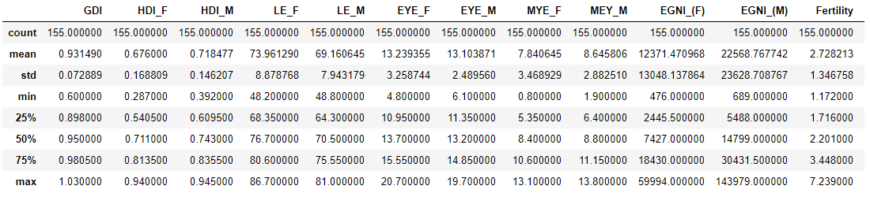

The above table represents a basic data structure. We see that the mean LE of females across the nations is approximately 74 years of age and that of males is 69 years of age. This shows that males have lower LE than females in general and this could be due to the difference in their genetic composition. I t is also observed that the average gross national income of female is 12371.47 and that of male is 22568.76. It is observed that the EGNI of female is less than male this could be due to the stereotypic nature of certain societies that will prevent girls from acquiring higher education. We on a similar note we can interpret the other parameters as well.

Fertility Rate (2018)

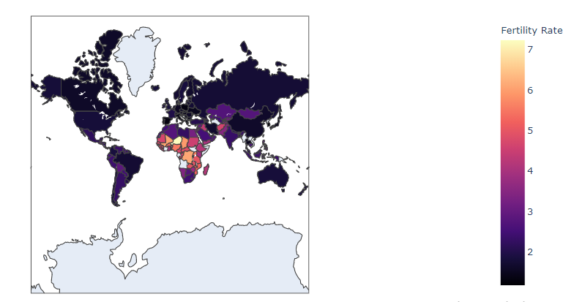

The above figure is a choropleth map which describes the fertility in 155 countries. The fertility rate is determined by the shade. Hence from the above map it is observe that Niger has the maximum fertility rate whereas countries like Ukraine, Poland, Iran, Canada, China has the least fertility rate.

Maternal Mortality Rate (2018):

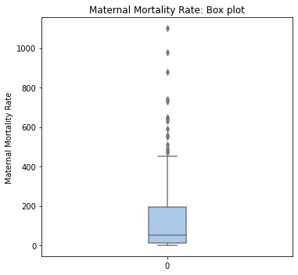The above boxplot gives the five-point summary of the maternal mortality rate in 2018. It is observed that the maternal mortality rate is right skewed. We also observe that the lower quartile is 13 and upper quartile 195. It is also observed that the maximum MMR is 1100 and minimum MMR is 1. We also observe from the above plot that there exist outliers, this indicates that there few countries whose maternal mortality rate is greater than the maximum MMR.

Labour Force Participation of Female (2018):

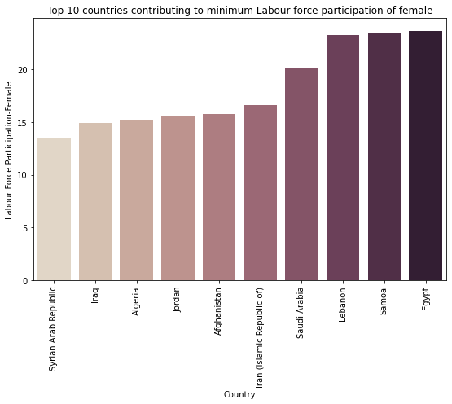From the above bar chart, it is observed that countries like Egypt, Saudi Arabia, Iraq, Afghanistan, Samoa are having the least labour for participation of female, thus this would directly affect fertility rate in these countries.

Mean Year of Education

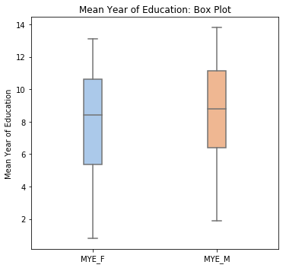From the above plot it is observed that, the median mean year of education for female is 8.5 years. We also observe that the mean year of education of female is left skewed which indicates that there are more countries with less than even 8.5 mean years of experience for women. We observe that the maximum mean year of education of female is 13.5 years and minimum mean year of education of female below 1 that means not educated at all. We also observe that lower quartile is 5.5 years which indicates that 25% of countries have mean years of education of female below 5.5 years and 75% of countries have mean years of education of female above 5.5 years.

On observing the box plot of mean year of education of male, the median mean year of education for male is 9 years. We also observe that the mean year of education of male is left skewed which indicates that there are more countries with less than even 9 mean years of education for men. We observe that the maximum mean year of education of male is 14 years and minimum mean year of education of male below 2 years. We also observe that lower quartile is 6.5 years which indicates that 25% of countries have mean years of education of male below 6.5 years and 75% of countries have mean years of education of male above 6.5 years.

Mean Year of Education of Female

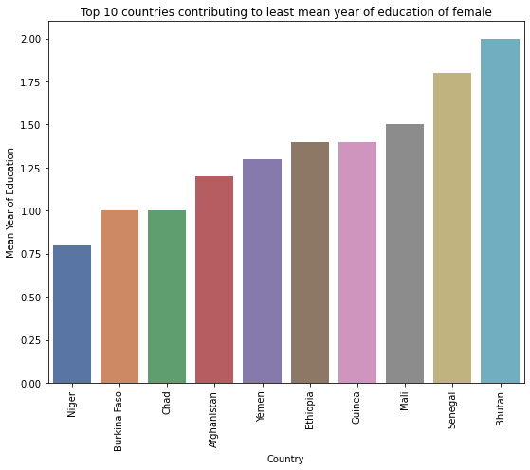From the above bar chart, it is observed that the countries like Niger, Afghanistan, Yemen, Bhutan, Mali are few among the top 10 countries who has the least minimum years of education of female. Thus, we can assume that these countries might have really high fertility because education always has an impact on fertility. More educated people are, they are more likely to adopt family planning practices which leads to reduction in fertility. As we had already seen from the choropleth map that Niger has the least fertility rate.

Life Expectancy

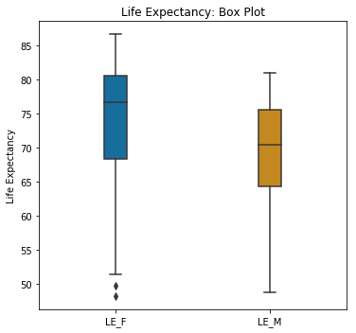From the above plot it is observed that, the median life expectancy for female is 72.5 years. We also observe that the life expectancy for female is left skewed which indicates that there are more countries with less than even 72.5 years of life expectancy for female. We observe that the maximum life expectancy for female is 82.5 years and minimum life expectancy for female is 52 years. We also observe that lower quartile is 68 years which indicates that 25% of countries have life expectancy for female below 68 years and 75% of countries have life expectancy for female above 68 years. We also observe that there exist outliers that means there are countries who has life expectancy of female much less than 52 years.

From the above plot it is observed that, the median life expectancy for male is 71.5 years. We also observe that the life expectancy for male is left skewed which indicates that there are more countries with less than even 71.5 years of life expectancy for male. We observe that the maximum life expectancy for male is 81.5 years and minimum life expectancy for male is 48-49 years. We also observe that lower quartile is 66 years which indicates that 25% of countries have life expectancy for male below 66 years and 75% of countries have life expectancy for male above 66 years.

Estimated Gross National Income

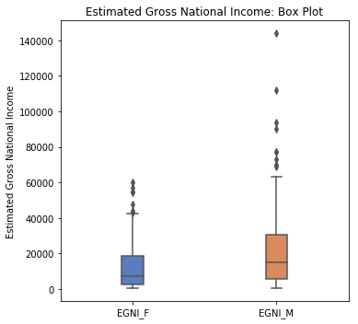From the above plot it is observed that, the median EGNI for female is 7427. We also observe that the EGNI for female is right skewed which indicates that there are more countries with more than even 7427 of EGNI for female. We observe that the maximum EGN for female is 59994 and minimum EGNI for female is 476. We also observe that lower quartile is 2445 which indicates that 25% of countries have EGNI for female below 2445 and 75% of countries have EGNI for female above 2445. We also observe that there exist outliers that means there are countries who has EGNI of female much more than 59994.

From the above plot it is observed that, the median EGNI for male is 14799. We also observe that the EGNI for male is right skewed which indicates that there are more countries with more than even 14799 of EGNI for male. We observe that the maximum EGNI for male is 143979 and minimum EGNI for male is 689. We also observe that lower quartile is 5488 which indicates that 25% of countries have EGNI for male below 5488 and 75% of countries have EGNI for male above 5488. We also observe that there exist outliers that means there are countries who has EGNI of male much more than 143979.

Human Development Index

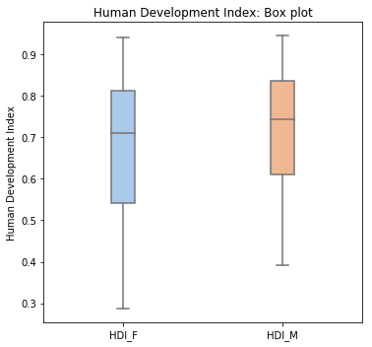From the above plot it is observed that, the median HDI for female is 0.71. We also observe that the HDI of female is left skewed which indicates that there are more countries with less than even 0.71 HDI for women. We observe that the maximum HDI of female is 0.94 and minimum HDI of female 0.28. We also observe that lower quartile is 0.54 which indicates that 25% of countries have HDI of female below 0.54 and 75% of countries have HDI of female above 0.54.

From the above plot it is observed that, the median HDI for male is 0.74. We also observe that the HDI of male is left skewed which indicates that there are more countries with less than even 0.74 HDI for men. We observe that the maximum HDI of male is 0.94 and minimum HDI of male 0.39. We also observe that lower quartile is 0.60 which indicates that 25% of countries have HDI of male below 0.60 and 75% of countries have HDI of male above 0.54.

Relationship between MMR and Fertility

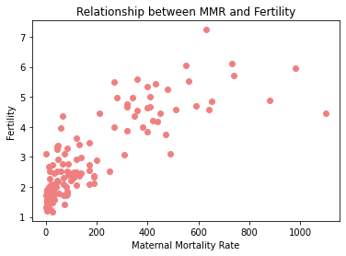We see that there is almost a positive and linear relationship between the variables. This means that as MMR increases, fertility will also increase.

SLRM (Simple Linear Regression Model), is a relationship between one dependent and one independent variable. MLRM (Multiple Linear Regression Model) is a relationship between one dependent and more than one independent variable. MLRM, is used mostly as we know that in real world, the value of a variable depends on not just a single variable. There are several variables involved in the prediction process.

**Simple Linear Regression Model**



On modelling the relation between fertility and MMR, we see that the regression coefficient is 0.83. This means that there is a positive and linear relationship between the variables i.e. with the increase of MMR by 1 unit, the fertility will increase by 0.83. This is the same as predicted in the above graph as well.

**Hence the fitted regression model is,**

**Y = 1.9148 + 0.0052 * x**

**i.e., Fertility = 1.9148 + 0.0052 * maternal mortality rate**

We observe from the above model that intercept is 1.9148 which means that when maternal mortality rate is zero fertility is 1.9148.

It is observed that the slope is 0.0052 which means that for one unit of change in maternal mortality rate fertility changes by 0.0052 amount.

**Fitting the regression model**

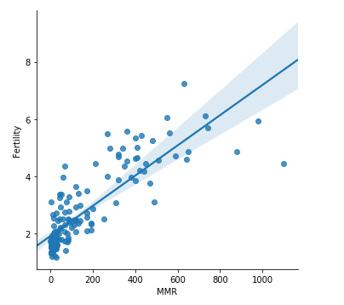

Predicting the fertility of Bangladesh based on simple linear regression model obtained above.

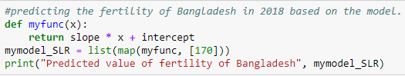

For the given value of maternal mortality rate of Bangladesh, the predicted value of fertility of Bangladesh is 2.8125.

**Analysis for Multiple Linear Regression model**

Mean Year of Education

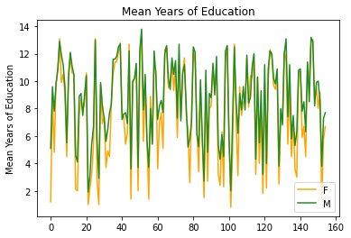From the above graph we see that the mean years of education is slightly higher for males than females. This could be due to the stereotypic nature of certain societies that will prevent girls from acquiring higher education. This could be a factor that affects the fertility rates.

Life Expectancy

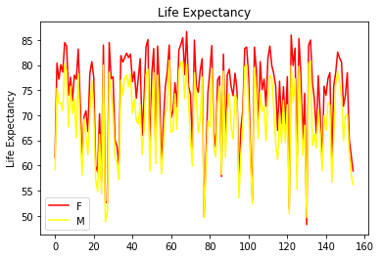

The plot of LE shows that both men and women have almost similar LE, with women having slightly higher LE than men.

Estimated Gross National Income

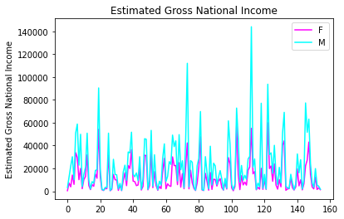On comparing the income, we see that the income of men is much higher than women. This could be due to the age-old stereotype that is present in societies which doesn't permit women to enter the earning world.

Human Development Index

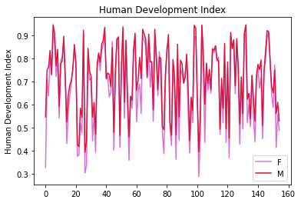

We see that the HDI of men is slightly higher than women in several nations. However, they are similar.

HDI is a very important aspect which needs to be given more importance. These indices will reflect the

Hidden parameters of a nation.

We will take the above variables analysed of women alone to study their impact on fertility.

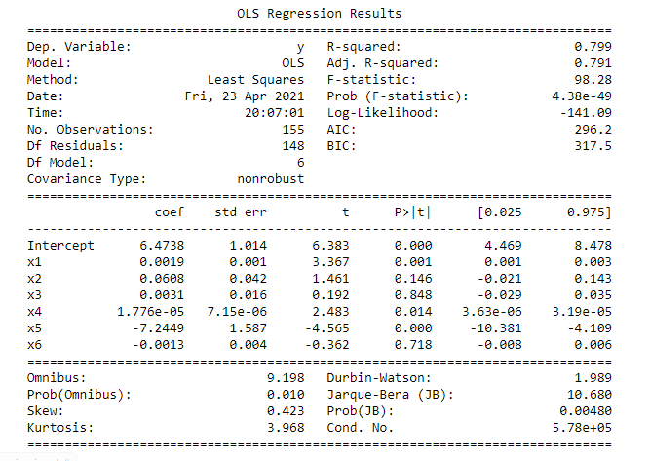

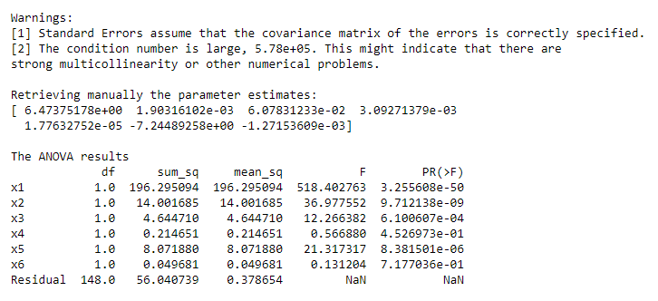

Thus, we have obtained the ANOVA table for the regression model that we fit. The Adjusted R Squared value is 0.79, which means that this model can explain about 79% of the variability in the dependent variable. Since this value is higher than 0.5, we can say that the model that we have is a good fit for the data. We have also obtained the regression coefficients of the independent variables.

**The model can be formulated as:**

*y = 6.4738 + 0.0019(x1) + 0.0608(x2) + 0.0031(x3) + 1.776e-05(x4) - 7.2449(x5) - 0.0013(x6)*

Thus, we see that most of the variables have a positive relationship with fertility i.e. with the increase in one, fertility will also increase. Only the coefficients of x5 and x6 are negative, which means that with the increase in x5 or x6, there will be a decrease in y (fertility). In the above model the regression coefficients can be interpreted as: the intercept term is the average value of fertility, when the regressor variables are constant (or zero). The coefficient of x1 says that, with increase of x1 by 1 unit, y would increase by 0.0019 amount, keeping other regressors fixed. The coefficient of x2 says that, with increase of x2 by 1 unit, y would increase by 0.0608 amount, keeping other regressors fixed. The coefficient of x3 says that, with increase of x3 by 1 unit, y would increase by 0.0031 amount, keeping other regressors fixed. The coefficient of x4 says that, with increase of x4 by 1 unit, y would increase by 1.776e-05 amount, keeping other regressors fixed. The coefficient of x5 says that, with increase of x5 by 1 unit, y would decrease by 7.2449 amount, keeping other regressors fixed. The coefficient of x6 says that, with increase of x6 by 1 unit, y would decrease by 0.0013 amount, keeping other regressors fixed.

Thus HDI_F and LFP_F have a negative impact on the fertility rates, while other variables in the model have a positive effect. This could be attributed to the fact that, as more women become a part of the work force, they tend to become more informed and aware about family planning. Hence, this would lead to a lower fertility rate.

**Hypothesis Testing:**

H0: beta0 = beta1 = beta2 = beta3 = beta4 = beta5 = beta6 = 0 i.e., they are insignificant

H1: At least one among the betas! = 0 i.e., they are significant

We see that x2, x3 and x6 have a p-value greater than 0.05, which means that we accept the Null Hypothesis for these and for the remaining variables we reject the Null Hypothesis. The acceptance of the H0 means that those variables are insignificant, they have less or no impact on the dependent variable.

Heatmap for understanding the correlation:

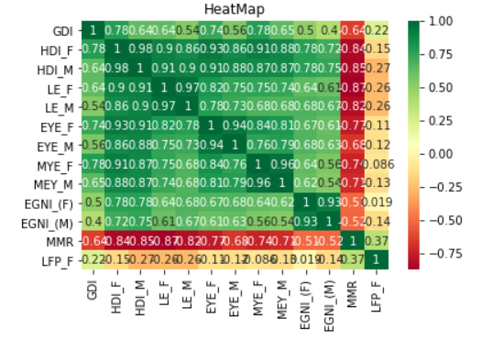 The heatmap will help us to understand the correlation types between the variables in the given dataset.

***India***

***Analysis of the Southern States***

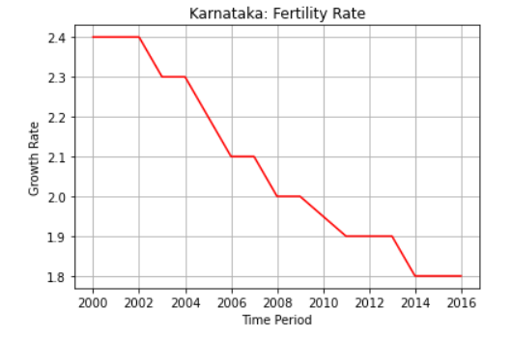

The above graph depicts the fertility rate of Karnataka. This graph shows us that the rate is decreasing in this state for the previous years. The time line used is from 2000 to 2016. This could probably be due to increase in awareness regarding various family planning techniques. Moreover, as more women enter into the labour force, they become aware and informed about the various way to lead an improved life. This is further clearly reflected in these rates.

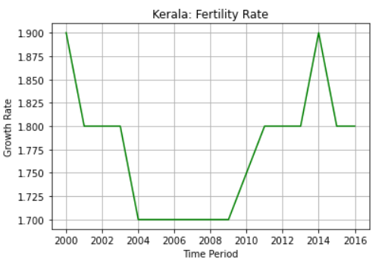

The fertility rate in Kerala shows almost an increasing trend. However, we do see that there is a sudden dip in 2002 until 2014. Kerala is regarded to be one among the best states in India with respect to their indices. On comparing with Karnataka, we see that Kerala is showing signs of improvement.

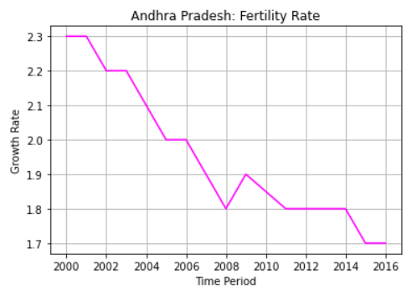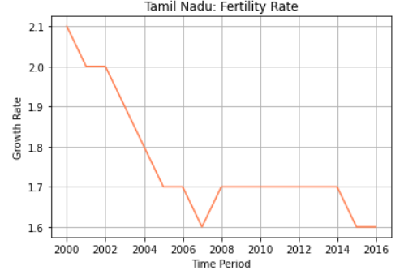

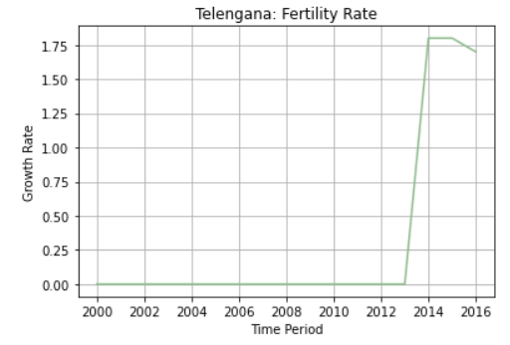 The rates in all the above states are decreasing, which is very evident from the trends in the graphs. Thus, we see that comparatively rates of Telangana are increasing. There is no data available for earlier time periods as Telangana was formed in 2014.

***Analysis of Northern States***

Here, we have chosen 5 states from North that have high fertility and comparatively are doing better in these terms than other states.

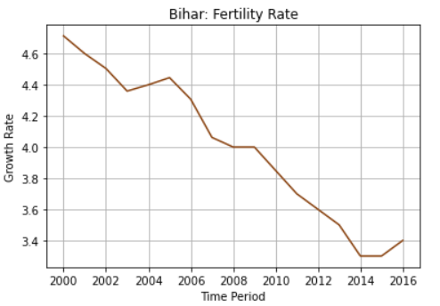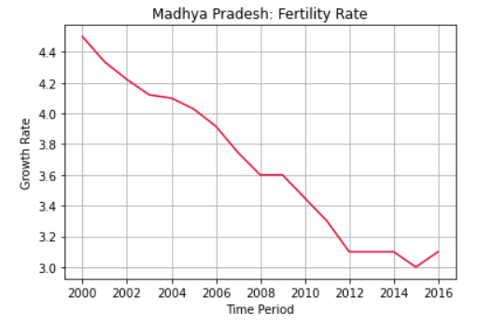

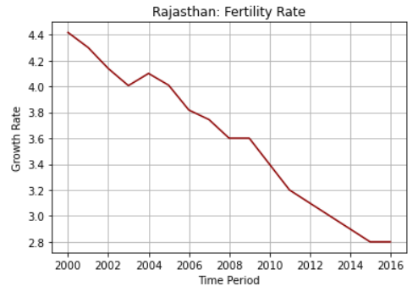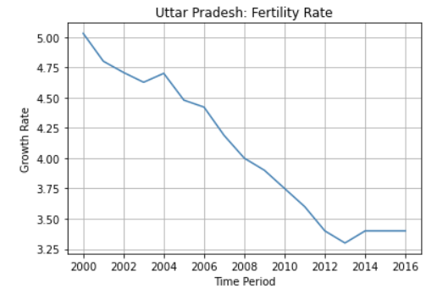

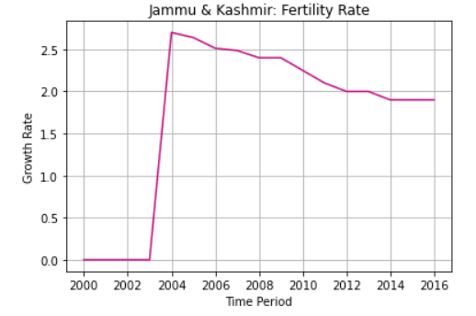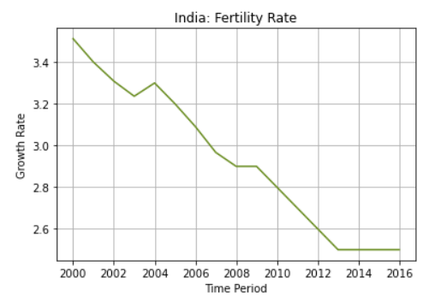

All the above states show a downward sloping graph, which means that they all have decreasing fertility over time. Compared to them only Jammu and Kashmir show a slight constant trend.

Comparing which state has better rate:

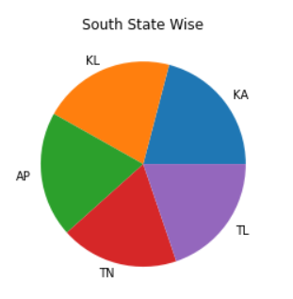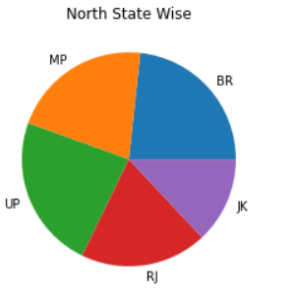

Kerala and Karnataka have highest in South. Bihar and UP have the highest in North.

A Time Series of year 2000 and 2016 for these states.

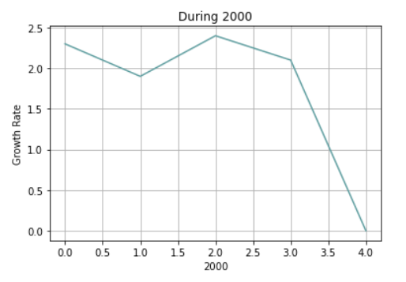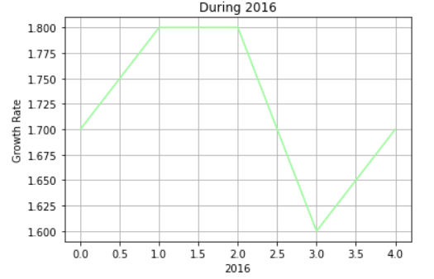

Thus, from the above two we see that during the year 2000, the lowest was around 0 and in the year 2016, the lowest is 1.6. This is a good change that we get to see. This probably shows that, due to improvement in technology the rates have improved. However, there is a drop in both the cases. Despite a large time, we see that rates haven’t improved significantly, as in 2000 the highest was around 2.5, while in 2016 it is 1.8 alone. This means that in course of time nations are seeing a decline in the fertility rates.

The below shows the summary of the Northern states taken for analysis.

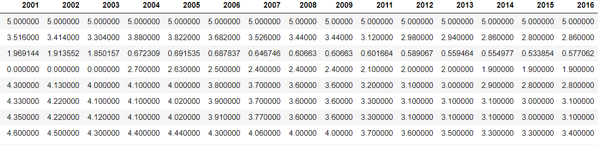

Below, we have the summary of the Southern states taken for analysis.

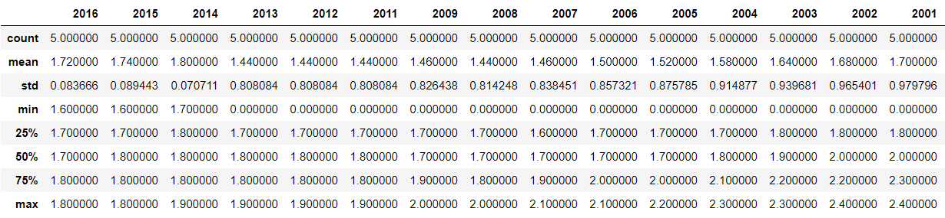

On comparing them both we see that in the year 2016, the mean in case of North is higher than South. This means that Northern states generally have higher fertility rates than Southern ones. On comparing the other years too, we see that Northern states have higher rates than Southern. This could be due to several reasons. South Indian mothers produce less babies compared to North Indian mothers. This is a common trend for decades. Less babies means more education and job opportunities for young adults after a couple of decades. That's a very important reason. South India dominates when it comes to higher education. Be it Engineering, Nursing, Medical or any other field. Technically, Maharashtra is also south of Vindhyas and follows the same trend as rest of South India.

Bihar has almost twice the population as Karnataka. But has nearly 1/5th the medical seats as Karnataka. That means every student aspiring to be a Doctor in Karnataka, has 10 times more chance compared to a student in Bihar. This shows the advantages of having lower fertility rates. One more reason for the same could be due to higher literacy rates in South compared to North. If we see the literacy rates of Southern states, we find that they are much higher than in the North. This is because of many initiatives launched by the princely states of Travancore and Mysore in the mid-20th century to bolster education in their states. The next boost came in Tamil Nadu when Kamaraj in 1965 introduced mid-day meal scheme. This ensured large scale retention rate in schools. This was soon followed by the Andhra Pradesh government.

On comparing with India’s average, we see that North is in par than South.

Now we can predict the future fertility rates of any state. Here, we are choosing Kerala and Madhya Pradesh.

For Kerala:

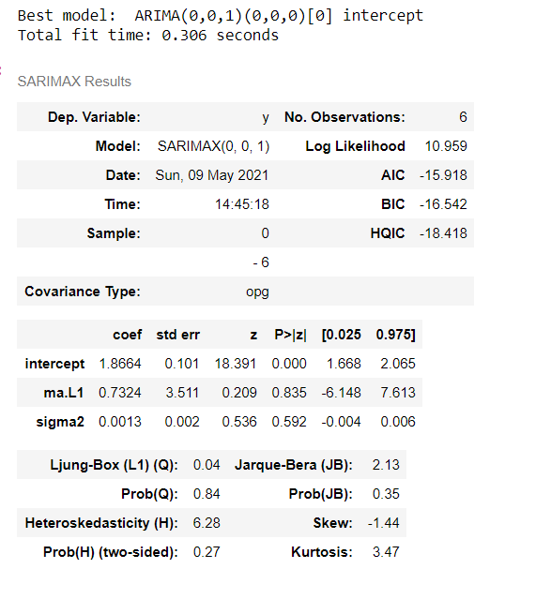

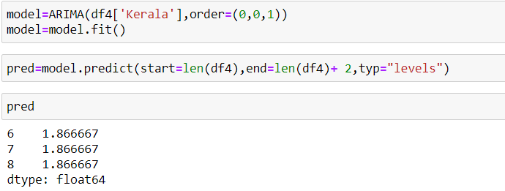

Thus, the above represents the predicted values for years 2017, 2018 and 2019.

For Madhya Pradesh

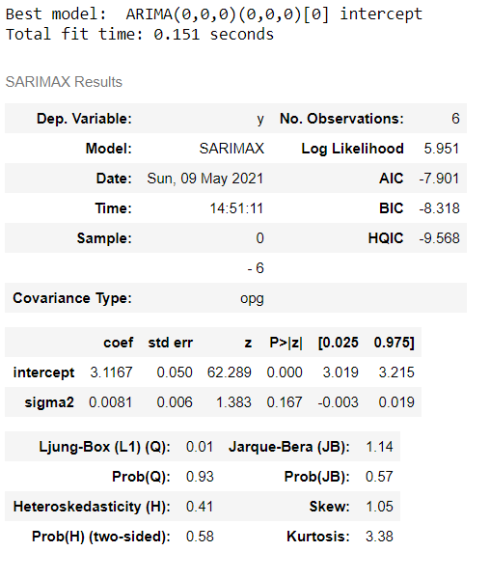

The above represents the predicted fertility values for Madhya Pradesh during the years 2017, 2018 and 2019. 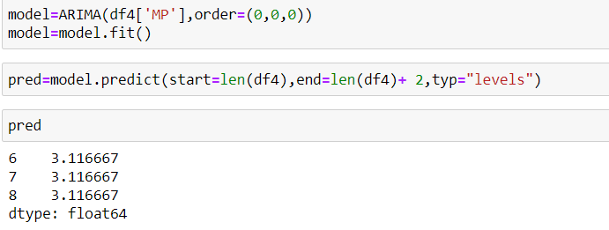

Hypothesis Testing:

Between Kerala and MP:

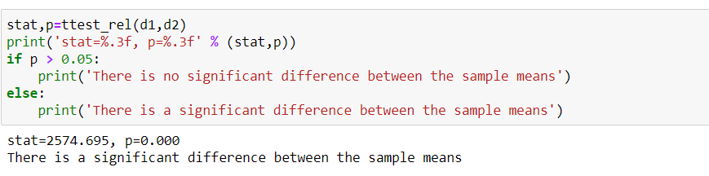

This clearly proves the above analysis that we did. There is a difference between the northern and southern states.

Obtaining the Lag Plots to check for autocorrelation:

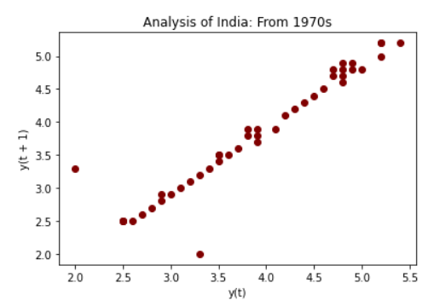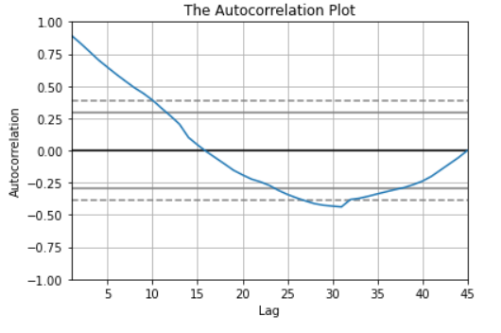

Thus, we see that there is a strong autocorrelation among the lag values. This means that they can be used for future prediction too.

We can plot the data of India to understand it’s distribution.

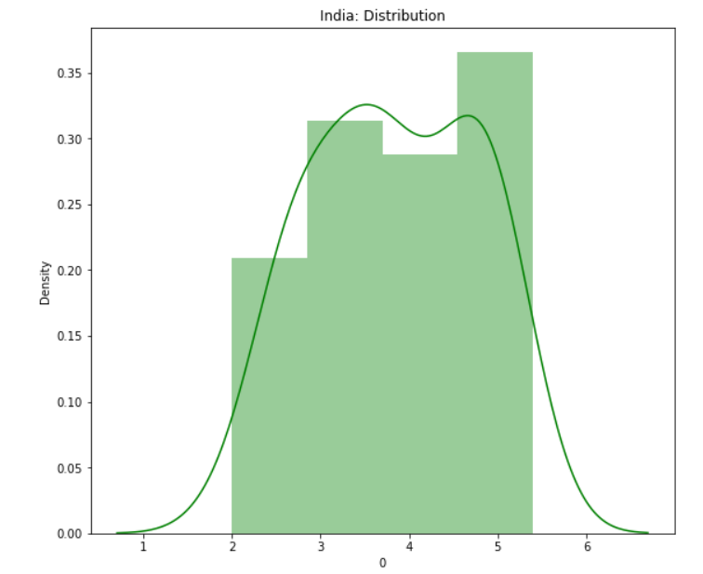

Thus, we observe that, the data does not follow an exact Normal distribution which can be understood evidently.

Now, we can understand the distribution patterns followed by south and north states that we took for analysis, during each year. This will help us to understand whether there are repeating years that have same distribution and if we can identify any pattern from the same.

For South:

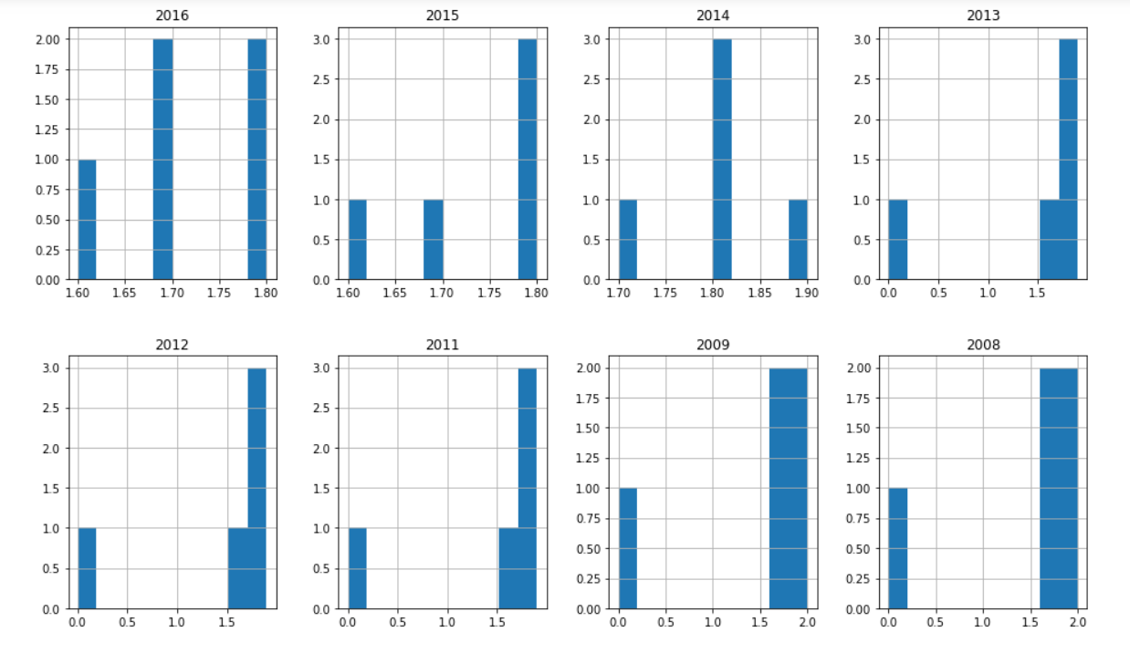

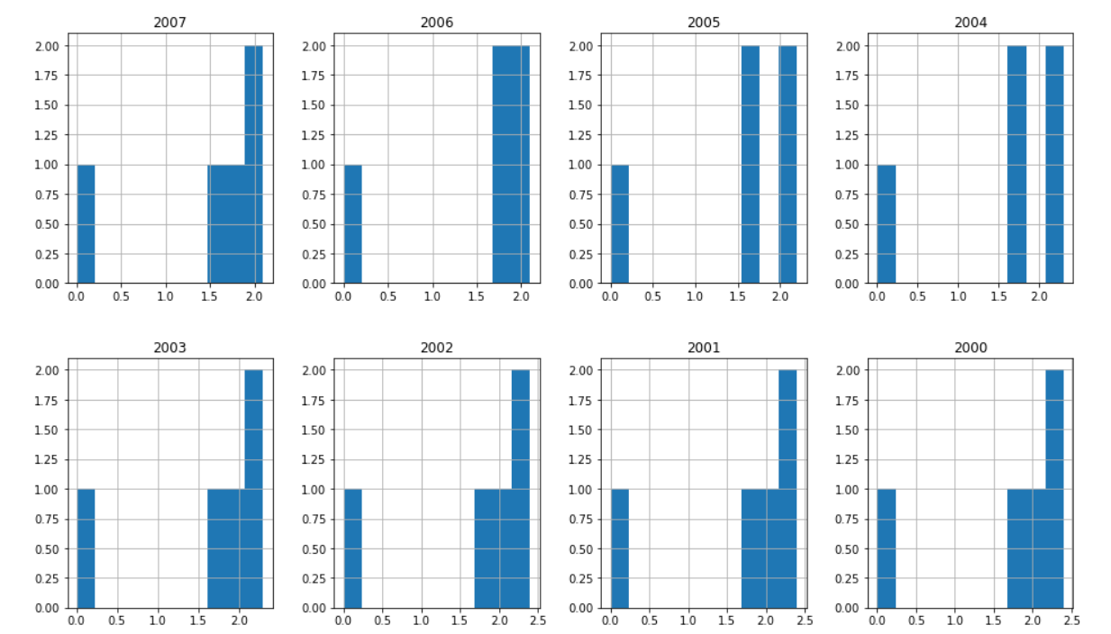

In south we see that during the years 2007, 2003, 2002, 2001 and 2000 there is a common distribution which is not seen afterwards. Also, the years towards 2016 see a similar distribution.

For North:

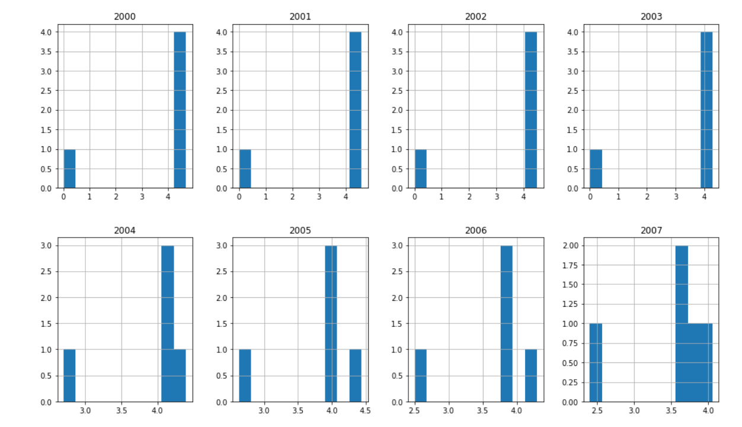

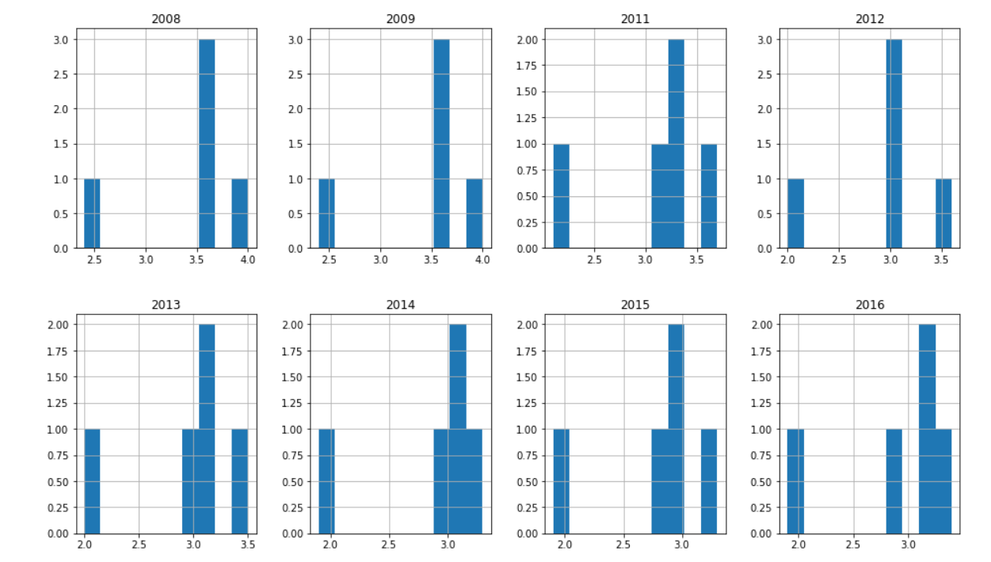

On observing north, we see that the years 2013, 2014, 2015 and 2016 have similar distributions. Also, initially up to 2007 as well they had similar distributions.

From both the analysis we couldn’t identify any particular pattern or trend per say. This shows that the fertility rates are not related to time periods.

We can plot a boxplot to check if there are any outlying values in the data set. Here, we are plotting for India.

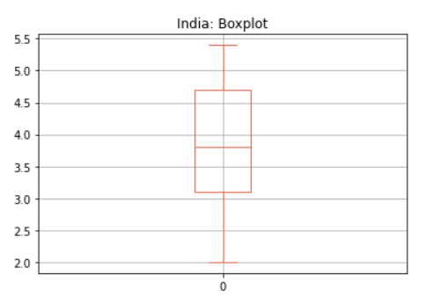

From the above boxplot we can infer that there are no outliers. The maximum fertility rate India has seen is 5.4, which is represented by the topmost line and the minimum is 2, which is represented by the bottom line. This represents a good data set from an analysis point of view.

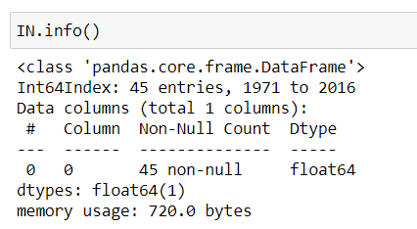

The “info ()” function will help in getting a summary of the data. The above represents the data types. It also gives a gist of the data frame.

***Data Modelling***:

Model Selection, Execution and Evaluation:

From the analysis above we will select the ARIMA model for analysis. This is due to the fact that when we performed ARIMA, we got a result that shows our data is stationary. Stationarity means that the statistical properties of the process generating time series do not change with a shift in time. We have predicted for 2 of the states of India; Kerala and MP. The ARIMA model consists of both the AR and MA components. The AR component is called the Autoregressive and MA is the Moving Average part. The AR part will consider the past values while the MA part will consider the error terms to make the predictions. A typical ARIMA model has 3 components – p, d and q, where “p” is the order of AR model, “q” is the order of the MA model and “d” denotes the number of differencing that is required to make the data stationary. These models have been represented previously in our analysis.

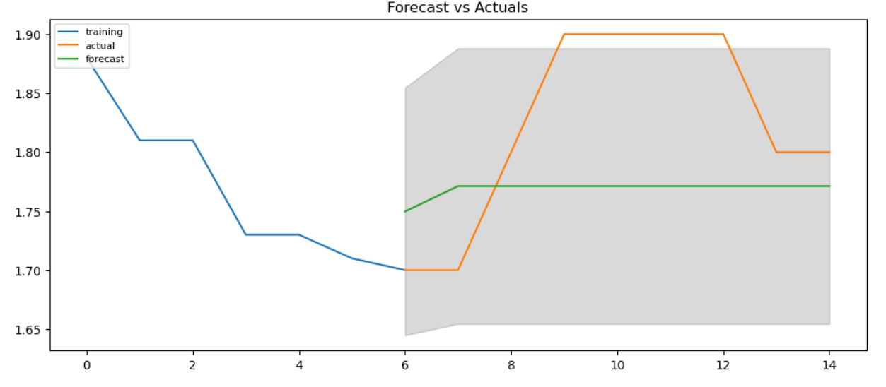

From the above graph and the predicted values that we have obtained earlier, we can say that there is stationarity in the data points and hence it is a good model.

***Presentation and Automation:***

Predictions, Presentation and Conclusions:

The predicted values are already presented above. From our analysis we understand that Northern states are much better in terms of fertility rates than southern ones. India, has seen a decline in its fertility rates over time. This could be both a good as well as a bad indication about the population. As time progress, there is technological advancements, developments and many more factors that will improve the knowledge and living conditions of women (and people). As that happens, they tend to become more aware about the different family planning techniques and other aspects, which further leads to a drop in these rates. This could also mean a decrease in population growth in the due course of time, which may be healthy, as it will increase the opportunities for all.

We have modeled the variable fertility with other factors that determine it. The regression model is good. We have predicted the future values as well. Both show a good trend. We also understand that Niger is the country that has highest fertility rate, about 7 children per women. However, owing to the financial background of the nation, we understand that this is not a good aspect. Niger is one among the poorest nations in the world. Such a high fertility rate could crush the economy, when the economy is struggling to keep up. Such nations have high rates as they are unaware about the various effects such huge populations can have. This is a trend observed that, the poorer the nation, higher is its fertility rate. There is a need to provide more education and knowledge to such nations to help them from going into a shortage of commodities that could arise from such a population spurt.

Looking from one dimension a lower fertility rate is actually good due to the reasons mentioned above. This will ensure that the population is under control and also equal (maybe more) opportunities for all.